There are different types of cloning vectors. Some commonly used cloning vectors are:
- Plasmids are circular, autonomously replicating DNA molecules widely used as cloning vectors. They can hold DNA inserts of sizes up to around 15 kb.
- Bacteriophages, also known as phages, are viruses that infect bacteria. Bacteriophages like lambda (λ) and M13 are often used as cloning vectors.
- Cosmids are hybrid vectors that combine the characteristics of both plasmids and bacteriophages. They are more stable than regular plasmids.
- Bacterial artificial chromosomes (BACs) are large cloning vectors used for cloning DNA sequences in bacterial cells and they can hold DNA segments up to 350 kb.

How Restriction enzymes produce sticky ends
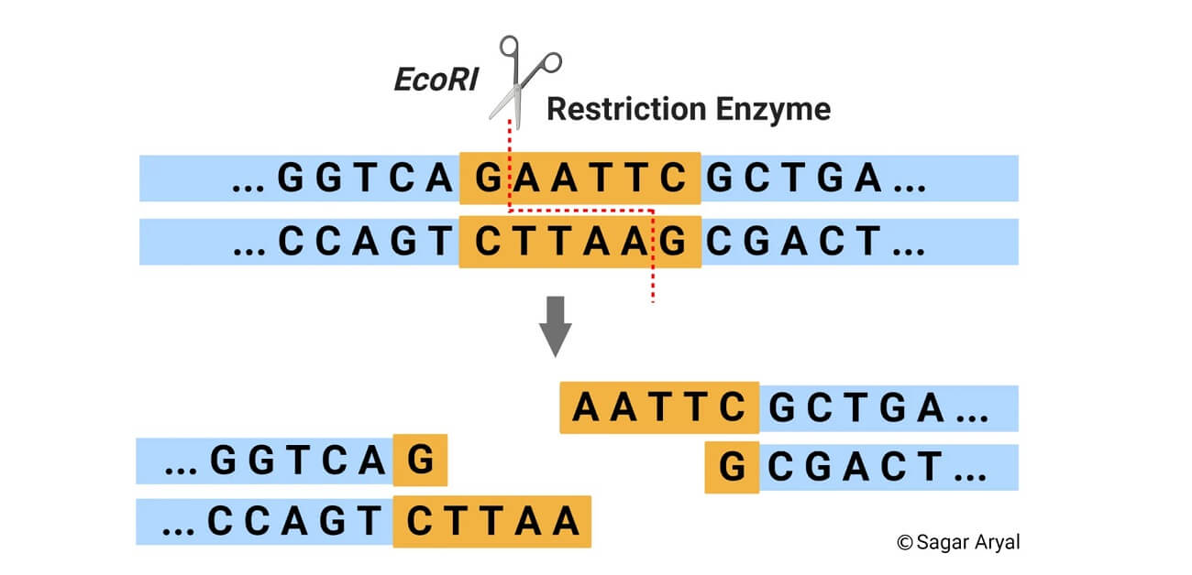

How Electroporation Works
- Preparation: Cells are suspended in an electrolyte solution, along with the substance (e.g., DNA plasmid) intended to be introduced.
- Application of Electrical Pulse: An electric field is applied through electrodes in a controlled manner. This pulse momentarily disrupts the lipid bilayer of the cell membrane.
- Formation of Pores: The electric field induces the formation of temporary nanopores in the membrane, making it permeable to macromolecules.
- Uptake of Molecules: Molecules in the surrounding medium (e.g., DNA or drug particles) can then pass through the pores and enter the cell.
- Resealing: After the pulse, the cell membrane quickly reseals itself, trapping the introduced molecules inside.

Types of PCR
PCR is of the following types:

Real-time PCR
In this type, the DNA amplification is detected in real-time with the help of a fluorescent reporter. The signal strength of the fluorescent reporter is directly proportional to the number of amplified DNA molecules.

Nested PCR
This was designed to improve sensitivity and specificity. They reduce the non-specific binding of products due to the amplification of unexpected primer binding sites.

Multiplex PCR
This is used for the amplification of multiple targets in a single PCR experiment. It amplifies many different DNA sequences simultaneously.

Quantitative PCR
It uses the DNA amplification linearity to detect, characterize and quantify a known sequence in a sample.

Arbitrary Primed PCR
It is a DNA fingerprinting technique based on PCR. It uses primers the DNA sequence of which is chosen arbitrarily.

Affinity Chromatography: Principle, Step and Uses
March 31, 2025 by Anjali Rawal
Chromatography is a widely used laboratory technique for the separation of components in a mixture based on their differential interactions with the stationary phase. This technique aids in the identification and purification of components and is applicable for both qualitative and quantitative analysis.
Affinity chromatography is a type of liquid chromatography, which utilizes the reversible biological interaction (affinity) between components in the mobile phase and a solid stationary phase for separation.
- It was discovered by Pedro Cuatrecasas and Meir Wilcheck in 1968.
- Affinity chromatography falls under the broader category of adsorption chromatography. However, it is highly specific and selective in comparison to adsorption chromatography.
- In affinity chromatography, the adsorption process is elective and specific, relying on the binding affinity between target biomolecules and a ligand immobilized on the solid support matrix.
- It enables the purification of target biomolecules (often a protein) based on their biological structure and function.
- Some ligand-target interactions include enzyme-substrate, enzyme-inhibitor, antibody-antigen, lectin-glycoprotein, etc.
- Ligands obtained from biological sources include antibodies, enzymes, proteins, glycoproteins, and others. Synthetic ligands used are metal chelates, boronates, biomimetic dyes, etc.
- Prepacked columns such as HiTrap, HiPrep, etc., are commercially available, facilitating rapid optimization.
